Assessment Schedule – 2015

Calculus: Apply differentiation methods in solving problems (91578)

Evidence
Q1 | Expected Coverage | Achievement  u | Merit  r | Excellence  t
(a) | 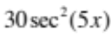 | A correct expression for the derivative.
(b) | 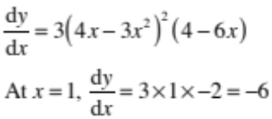 | Correct solution with correct derivative.
(c) | 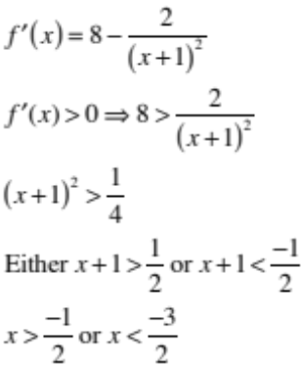 | Correct derivative. | Correct solution with correct derivative.
(d) | 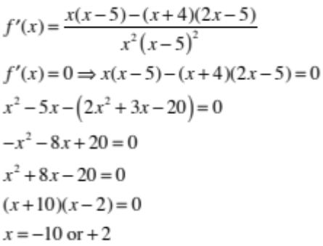 | Correct derivative. | Correct solution with correct derivative.
(e) | Let V = volume (m³)  S = slant height (m)  h = height (m)  r = radius (m)  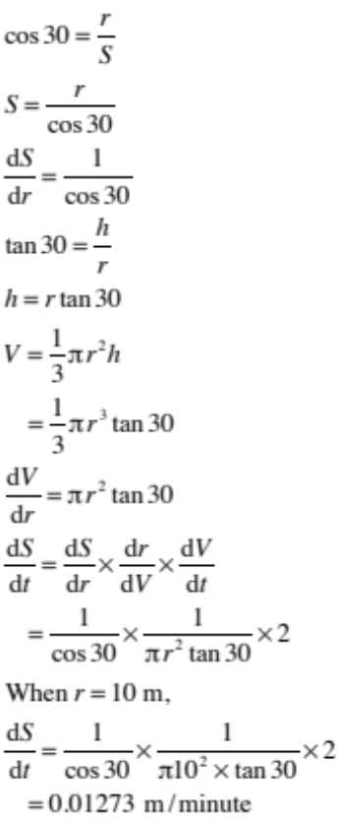 | 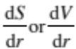  correct. | Valid statement of the relationship between rates. | Correct solution with correct derivatives.

NØ | N1 | N2 | A3 | A4 | M5 | M6 | E7 | E8
No response; no relevant evidence. | ONE answer demonstrating limited knowledge of differentiation techniques. | 1u | 2u | 3u | 1r | 2r | 1t with minor error(s). | 1t

Q2 | Expected Coverage | Achievement  u | Merit  r | Excellence  t
(a) | 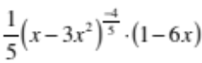 | A correct expression for the derivative.
(b) | 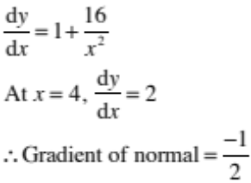 | Correct solution with correct derivative.
(c)(i)  (ii)  (iii) | 1. x = 1  2. x = –1, 1, 2  3. –1 < x < 1  3  Does not exist. | Two correct answers. | Four correct answers.
(d) | 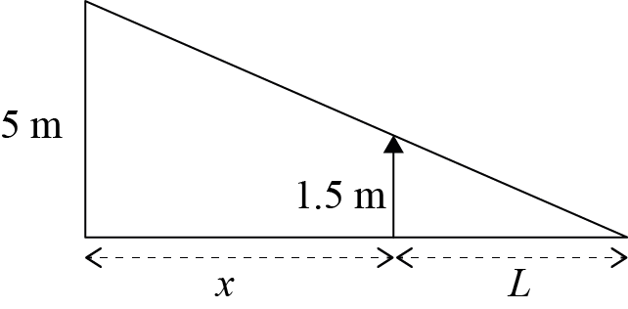  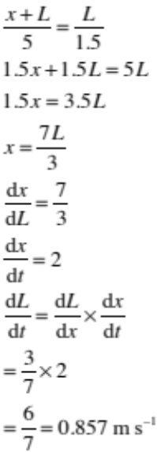 | 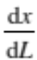 correct. |  | Correct solution with correct derivatives.  (Units not required.)

(e) | Depth of water = x  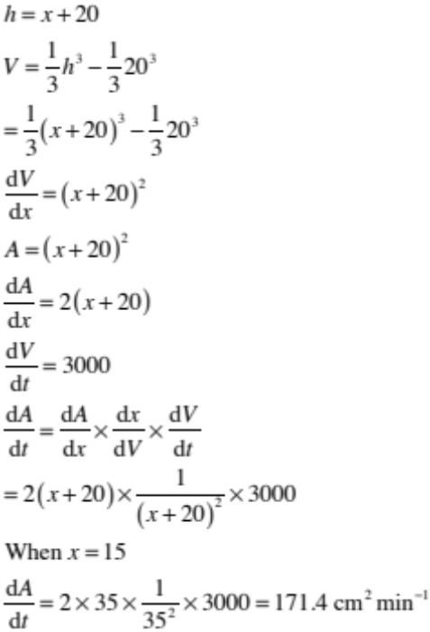 | Correct  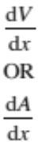 | Correct  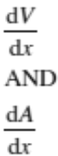 | Correct solution.

NØ | N1 | N2 | A3 | A4 | M5 | M6 | E7 | E8
No response; no relevant evidence. | ONE answer demonstrating limited knowledge of differentiation techniques. | 1u | 2u | 3u | 1r | 2r | 1t with minor error(s). | 1t

Q3 | Expected Coverage | Achievement  u | Merit  r | Excellence  t
(a) | 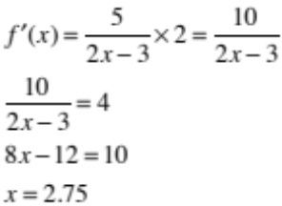 | Correct solution with correct derivative.
(b) | 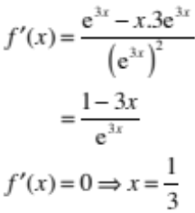 | Correct solution with correct derivative.
(c) | 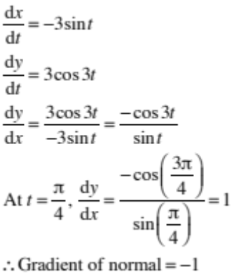 | Correct 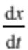 and 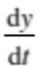 | Correct solution with correct derivatives.
(d)(i)  (ii) | 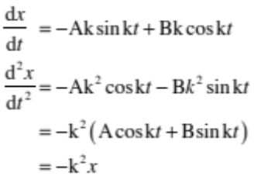  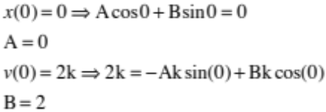 | Correct 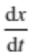  Or 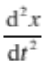  Consistent with incorrect | Parts (i) and (ii) both correct.
(e) | 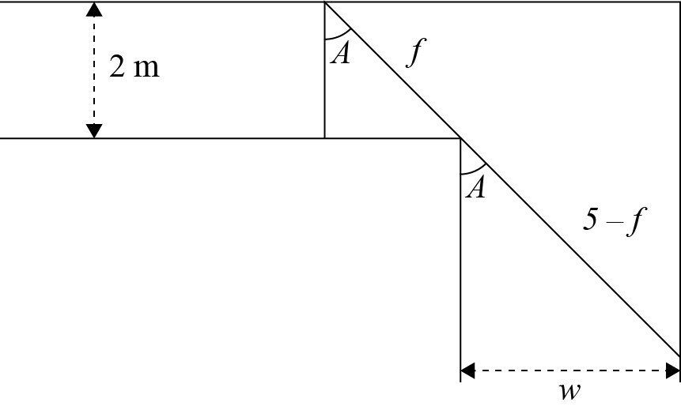  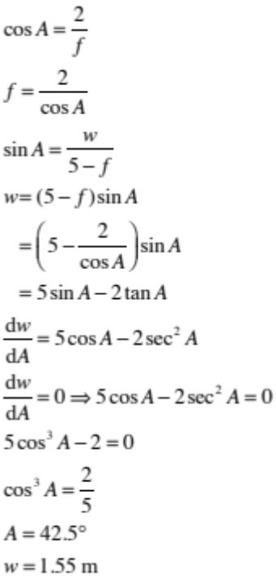 | Differentiate corretedly related but incorrect expression for w. | Correct 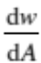 | Correct solution.

NØ | N1 | N2 | A3 | A4 | M5 | M6 | E7 | E8
No response; no relevant evidence. | ONE answer demonstrating limited knowledge of differentiation techniques. | 1u | 2u | 3u | 1r | 2r | 1t with minor error(s). | 1t

Cut Scores
Not Achieved | Achievement | Achievement with Merit | Achievement with Excellence
0 – 7 | 8 – 12 | 13 – 18 | 19 – 24

